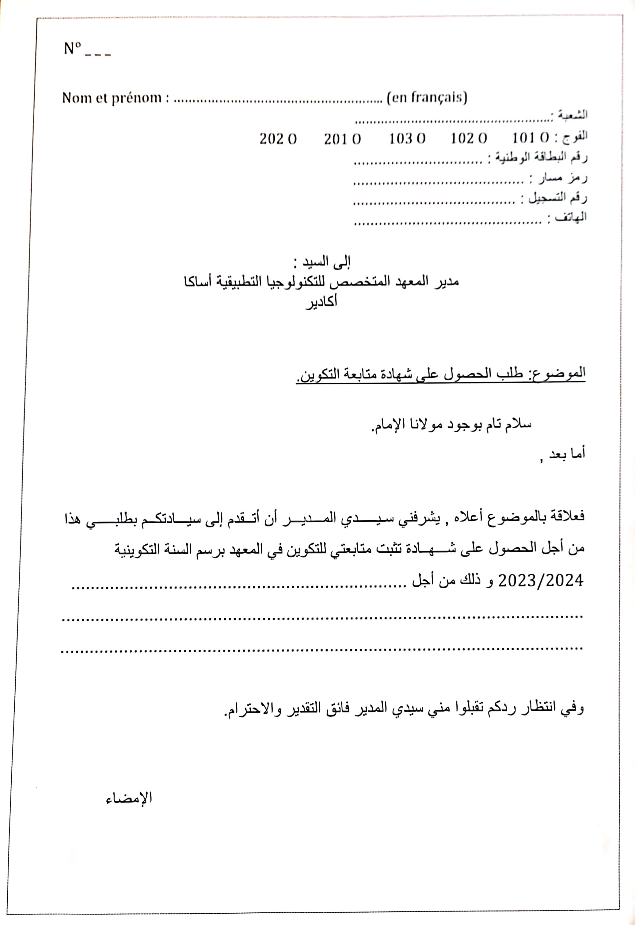

2024/2025

2024/2025

[CamScanner](https://v3.camscanner.com/user/download)